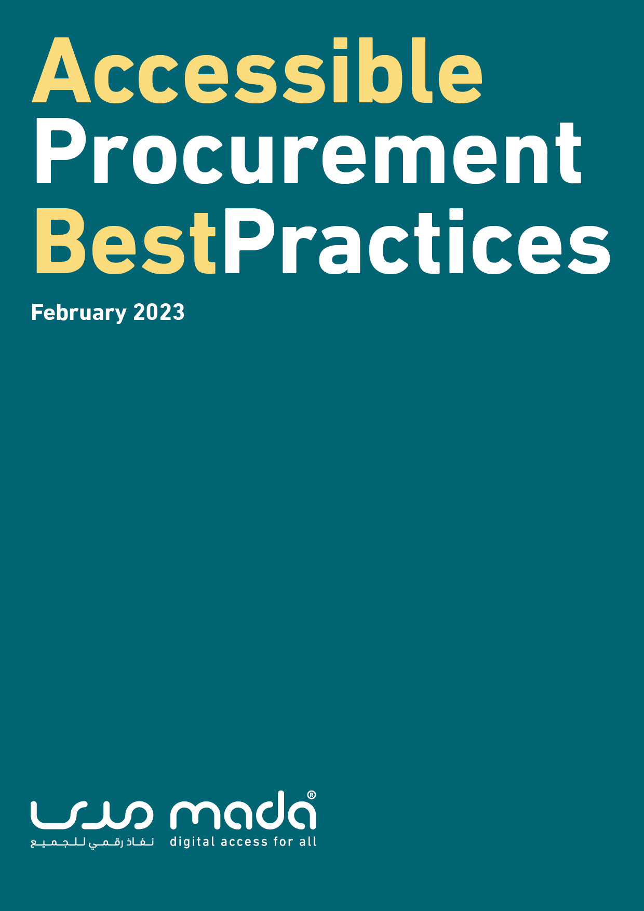

Accessible Procurement Best Practices

September 2021
1st Edition

Acknowledgements:
The “Accessible Procurement Best Practices” report was developed by Mada Center, Qatar, under the supervision of Ms. Maha Al-Mansouri, CEO, Mada Center, Qatar. The report was edited by Mr. Anirban Lahiri, Dr. Achraf Othman, and Ms. Amani Ali Al Tamimi.

Please cite the work as follows:
Lahiri, A., Othman, A., &amp; Al Tamimi, A. A. (2021). Accessible Procurement Best Practices (First Edition, Vol. 1). Mada Center, Qatar.

Accessible Procurement Best Practices © 2021 by Mada Center, Qatar is licensed under Attribution-NonCommercial-NoDerivatives 4.0 International

Table of Contents
1. Introduction 6
1.1 What is Accessible Procurement? 7
1.2 What is Accessible Procurement Policy? 7
1.3 Importance of Accessible Procurement and Related Policy 8
1.4 United Nations Convention on the Rights of Persons with Disabilities 10
1.4.1 Article 9- Accessibility 11
1.5 Beneficiaries of Accessible Procurement 14
2 ICT Accessibility Procurement Policy Model 16
2.1 What is the ICT Accessibility Procurement Policy Model? 16
2.2 Main Aim of the Accessible Procurement Policy 17
2.2.1 Accessibility and Equality 17
2.2.2 Reconciling Social and Economic Approaches to Public Procurement 18
2.2.3 Incentivizing Market of Accessible ICT Goods and Services 19
2.2.4 Supporting Accessible ICT Product and Service Innovations 20
3 ICT Accessibility Procurement Policy Model Implementation Phases 21
3.1 Organize and Raise Awareness 21
3.2 Review Existing ICT and Procurement Policies 22
3.3 Adoption and Implementation of appropriate International ICT Accessibility Procurement Standard 25
3.4 Development of Procurement Guidelines from Adopted Model Policy 26
3.5 Public Awareness of ICT Accessibility Procurement Policy 27
3.6 Proliferate Implementation Across Various Organization 28
3.7 Review and Monitor Policy Implementation 29
4. Conclusion 31
References 32
Appendix 1 – Abbreviations 34
Appendix 2 – Core Assistive Technologies 34
Appendix 3 – Clarification of Tender 36
Appendix 4 - Functional Performance Statements 41
Appendix 5 - Example of Product Accessibility Template 48
Appendix 6 - 9 Steps to Procuring Accessible ICTs for Inclusive Education (G3ICT) 52
Appendix 7 - The Five Procurement Stages 59

Introduction
The advent of Information and Communication Technology (ICT) has immensely impacted the enablement of Persons with Disabilities (PWD) to contribute towards tasks and roles that were previously unseen possible. This has become more applicable over the past decade where ICT has made major advancements and played an increased role in empowering PWD across various domains in life such education, employment, community, and home. Various technologies from Interactive Smart Boards in classrooms to Home Automations Systems have allowed PWD to perform related tasks independently and thus lead a better quality of life.

However, it is unavoidably important to offer the suitable ICT tools that provide adequate accessibility features across all domains of society (e.g. education, employment, home, etc.) to ensure the full and active participation of PWD in the community. It is crucial to plan and ensure that workstations, software, platforms and content are available in a way that allows full access which requires careful thought and implementation.

This best practice report pertains to exploring the challenges and processes surrounding to support organizations in promoting inclusion through ICT by ensuring the procurement of accessible platforms that will support the access needs of PWD within the environment.

1.1 What is Accessible Procurement?
Organizations must ensure that ICT platforms are usable by persons with disabilities by including accessibility criteria in the procurement processes of purchasing goods, services, and facilities. The primary aim for including accessibility criteria in ICT public procurement is to provide more equitable access to ICT office equipment such as phones and computer systems for organization staff and visiting clients with disabilities. These accessibility criteria must evaluate the incorporation of accessible design and features in items to be procured.

Accessible procurement involves identifying appropriate products or services that meet the accessibility requirements and if it is not the case then documenting the reasons for this not to be possible. There are a number of internationally recognized available checklist of procurement considerations and assessment toolkits to implement accessible procurement guidelines within an organization.

1.2 What is Accessible Procurement Policy?
Accessible procurement guidelines are increasingly being integrated into various public procurement policies that define the criteria, and expectations of services and goods being purchased by the government sector and related government funded programs. The implementation of Accessible Procurement policies has been recognized to be an effective tool to promote the accessibility of ICT equipment, software, applications, and services purchased by the public sector, including by education system institutions of all levels. Accessible procurement policies are implemented as part of the general procurement programs of private and public sector organizations.

The following are well recognized accessibility public policy activities that defines accessible procurement policies and guidelines within them.

- Section 508 of the Rehabilitation Act in the United States - governing the federal government purchase, development, maintenance, and use of accessible electronic and information technology)
- ETSI EN 301 549 - the European accessibility standard developed to support the European Commission’s rules that add accessibility criteria to the public procurement of ICT products and services in Europe)
- WCAG 2.0 / 2.1 – Referenced in both Section 508 and ETSI EN, WCAG 2.0 is a standard that covers a wide range of recommendations for making web content more accessible. The guidelines are intended to make web content and applications accessible, including on mobile devices, to a wider range of people with disabilities. Further to that the WCAG has published updated guidelines since the release of both Section 508 and ETSI EN. The current published version is WCAG 2.1 and similar to WCAG 2.0 it covers elements of Accessible Guidelines for developing web content and services that can be implied on vendors while procuring and developing digital content and services.

1.3 Importance of Accessible Procurement and Related Policy
The practice of Accessible Procurement offers a critical path towards achieving the ultimate objective of an overall accessibility policy. The organizational commitment of implementing accessible environments, and ICT platforms and services results in being a driving force to transform the onus of developing and making available accessible solutions towards the vendors and manufacturers themselves. The growth in demand of implementing accessible organizational spaces through following accessible procurement leads to having a ripple effect in terms encouraging manufacturers and vendors to invest in integrating accessibility features within their products and services.

Incentivizing vendors and manufacturers (external organizations) to offer accessible goods and services while practicing accessible procurement standards (internal organizational culture) allows to create an accessible ecosystem over time by simultaneously committing towards providing accessible environments from within and outside the organization. Considering the requirement of accessibility in purchased goods and services from the beginning of the procurement process and involving the vendors accordingly is logistically and financially more efficient in the long term compared to accommodating for accessible requirements on an as required basis. The prior approach allows an organization to readily accommodate PWD at any time without having to take up extra cost and design challenges to retrofit in-accessible systems.

Lastly, implementing an accessible public procurement policy plays a vital role in raising awareness of accessibility needs and solutions amongst vendors, manufacturers and the commercial market in general. The engaged attention of innovators and entrepreneurs can potentially result in creating new commercially viable accessible goods and services. This allows to ultimately create opportunities for developing a sustainable market space for accessible goods and services on a national and regional scale.

United Nations Convention on the Rights of Persons with Disabilities
The United Nations Convention on the rights of persons with disabilities, UNCRPD, was adopted in 2006 together with the Optional Protocol, OP. According to the United Nations, the convention is intended to ‘promote, protect and ensure the full and equal enjoyment of all human rights and fundamental freedoms by all persons with disabilities, and to promote respect for their inherent dignity.’ People with disabilities as relates to the convention include those with long-term mental, physical, sensory, or intellectual impairments who are hindered from achieving a full participation in society due to various barriers. The UNCRPD guides and enhances the understating of significance of accessibility in allowing equal opportunity to people with disability. Accessibility allows people with disability to ‘live independently and participate fully in all aspects of life’. Enforced in 2008, the convention set the standard for understanding and implementing the rights of people with disabilities globally.

The UNCPRD comprises a political and legal commitment of the international community to include the perspectives of people with disability and the disability concept in development and other societal aspects. The United Nations contends that the CRPD differs from other documents which propagate the perspective of people with disability as beneficiaries and recipients of development policy. This is because the convention regards this demographic as co-determinants and agents of development policies whose input and contribution are of significance. The UNCRPD requires the state parties to protect and promote the human rights of people with disabilities and ensure they can lawfully enjoy these rights. Additionally, the parties are required to promote and facilitate full equality of people with disabilities under the law.
The UNCPRD contributes to shifting the aforementioned perspective of regarding people with disabilities as cases of charity and social protection. It advocates for regarding them as full members of society with equal rights as everyone else. The UNCRPD has a preamble in accordance with the civil law tradition, comprising of 25 subsections that focus on sustainable development. For example, subsection e of the preamble contends that disability is an evolving concept which results from ‘the interaction between persons with impairments and attitudinal and environmental barriers that hinders their full and effective participation in society on an equal basis with others’.

UNCRPD comprises of 50 articles which address diverse concepts. For example, article 3 outline the Convention’s general principles, article 4 is concerned with the general obligations of the parties, while articles 5-32 comprise the rights of people with disabilities and the state parties’ obligations towards them. Article 9 of the convention focuses on accessibility.

1.4.1 Article 9- Accessibility

Article 9 of the UNCPRD aims to empower people with disability participate in society without restrictions and live independently. The article requires state parties to facilitate the removal of barriers and obstacles to accessibility such that people with disabilities can have a fulfilling and all-encompassing experience as everyone else in society. The state parties are to fulfil this requirement in different sectors including the procurement of goods and services. The article also requires that state parties facilitate the training of other stakeholders on issues pertaining to accessibility, and ensure that private entities who offer services and products to the public also comply with the convention. The premise of article 9 is that accessibility is a developmental concern as well as a human rights issue.
Member states can realize social, economic, political, and social inclusion by advocating for and facilitating accessibility for people with disabilities. Article 9 fosters the realization of human rights by ensuring people with disabilities are well taken care of in society. However, this can only be achieved once people with disabilities have equal access to quality education, information, shelter, work, and other significant aspects in society. Ensuring people with disabilities can fully enjoy their human rights calls for policy intervention accompanied with implementation procedures that facilitate the removal of barriers and provision of accommodation, which will ensure full participation and equal access. The United Nations contends that accessibility as applied to people with disability relates to services, items, spaces, and places, virtual or physical, that are ‘easily approached, reached, entered, exited, interacted with, understood or otherwise used.’
Beyond being a right for people with disabilities, the United Nations also affirms that accessibility is a way to ensure they can exercise their freedoms and participate equally with other societal members. Article 9’s approach to accessibility also includes an aspect of universal design. This can be seen in subsection h of the article, which contends that member states are required to take measures ‘to promote the design, development, production and distribution of accessible information and communications technologies and systems at an early stage, so that these technologies and systems become accessible at minimum cost’. The concept of universal design is also present in subsection a of the article, relates to intentionally designing programs, products, environments, and services to be usable by all people without the need for specialized design or other forms of adaptation.

Accessibility enables and facilitates a valued existence for people with disabilities, not to mention their contribution to the diversity and well-being of their communities. By advocating for the full participation of people with disability to the society, the convention acknowledges that accessibility enhance these people’s sense of belonging, and, in so doing, promotes the social, economic, and human development that allows for poverty eradication.

Aside from that, the convention also portrays the significance of including matters pertaining to disability in sustainable development agendas. The United Nations has spearheaded the discourse on accessibility and development, as evidenced by internal development goals like the 2030 agenda for sustainable development.

Below is a visual representation of the number of SDG indicators that address disability and advocate accessibility. 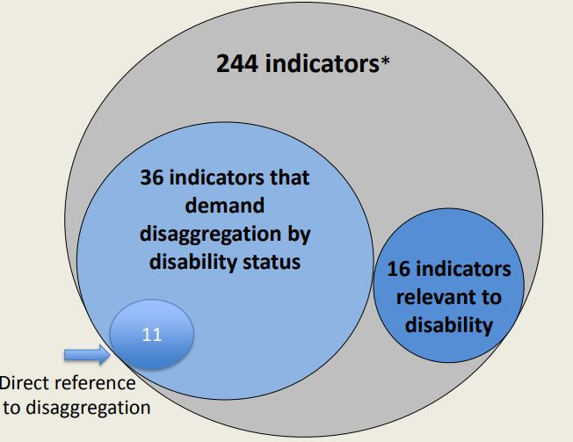
Figure 1: SDG Indicators and Disability
In addition, as illustrated below, eleven of the 17 SDG goals are also relevant to disability.

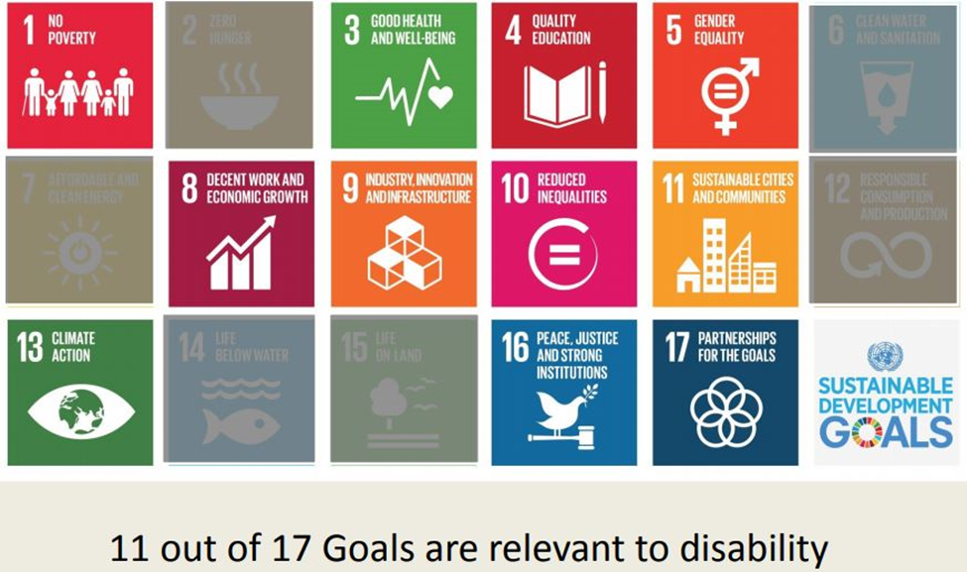
Figure 2: SDG Goals and Disability

Beneficiaries of Accessible Procurement
Increased availability of accessible solutions and environments within organizations can benefit staff members, clients, vendors, organizational finances, society at large:
- All staff members and clients would benefit from being able to use services and goods more effectively.
- The organization would benefit from reducing the need to provide expensive alternative channels for clients who cannot use particular services and goods. Designing and planning for accessibility from the start will prevent the need for adding accessibility at the end.
- The vendors would benefit from an increased customer base that includes PWD clients.
- The public sector can influence vendor supply chains to produce accessible services and goods which can be purchased by customers beyond the public sector.
- Society at large benefits through the inclusion of more citizens in social, economic, and cultural life.

ICT Accessibility Procurement Policy Model

2.1 What is the ICT Accessibility Procurement Policy Model?
The ICT Accessibility Procurement Policy Model aligns with global best practices for ICT Procurement and provides the following levels of guidance:
- High-level policy guidance to regulators and policy makers on developing national, regional or organizational level procurement policies that incorporate accessibility in a meaningful, measurable and practical way.
- Practical advice to procurement officials and project managers on how to immediately begin to incorporate accessibility into their procurement exercises.
It explains the need for public procurement agencies at all levels to mandate accessibility to:
- promote employment of people with disabilities and;
- create a market for ICT accessible products and services.
The ICT Accessibility Procurement Policy Model provides sample language for policy makers to consider across the main stages of procurement (including in calls for tender, assessment, selection processes, evaluation and review). It references a product accessibility template and a set of functional performance statements, which can be used to assess a range of ICT accessibility features (based on existing accessibility standards of the United States Section 508 or the European ETSI EN 301 549). It can be used to:
- Add accessibility into existing procurement policies
- Develop stand-alone ICT procurement policies at different levels of government, including municipal and regional, to complement existing policies
- Develop or update an ICT accessibility procurement policy at an organizational level.
The following sub-section outlines the main elements to develop and implement an Accessible Procurement Policy.

2.2 Main Aim of the Accessible Procurement Policy
The policy intends to outline guidance on implementing accessibility requirements for goods and services within their procurement cycle. It should highlight a masterplan to integrate accessibility while procuring goods and services (as applicable) without the limitation of unreasonable added expense and delay.

2.2.1 Accessibility and Equality
The values of accessibility and equality play a considerable role in incorporating accessibility public procurement policies and ensuring the availability of accessible ICT platforms. The primary challenges towards accessibility are beyond the physical access to the environment and also include obstacles for accessing information (via print and electronic means), and communication. For instance, as the height of an office desk can impact its usability by wheelchair users unless the desk has an “height-adjustment” feature similarly, the usability of a computer or smartphone to access relevant information by a blind user may be hindered without the incorporation of appropriate Assistive Technologies (e.g. Screenreader application) into these devices. The practice of Accessible Procurement Policies involves taking steps that allow to overcome these challenges and offer a greater inclusive environment for individuals with disabilities by ensuring that all items procured has a minimum level of accessibility features to cater towards one’s physical and/or digital accessibility needs.
It has been internationally recognized by the United Nations Convention for Rights of People with Disabilities (UNCRPD) that there is a key challenge of incompatibility between individuals and their environment which prevent PWD to perform task independently. This concept of implementing barrier free environment to provide full and effective equal participation in society amongst PWD is enhanced by the implementation of an Accessible Procurement Policy. Such a policy ensures the implementation of accessible goods and services within the environment and leads to eliminating factors that impede access and participation of PWD within various aspects of the society.

2.2.2 Reconciling Social and Economic Approaches to Public Procurement

The expenditure on strictly procuring accessible goods and service maybe perceived as an organizational financial burden. It can be argued that governments should spearhead such initiatives to expand the range of availability and demand for accessible goods and services. However, traditional public procurement policies have involved prioritizing cost-benefit aspects of goods and services throughout the procurement policies. The UNCRPD seeks to minimize such barriers by promoting the implementation of concepts such as Universal Design within ICT goods and services. UNCRPD Article 9 obligates organization to identify and remove ICT barriers including barriers to electronic and emergency services. The convention expresses the fact that implementation of Accessible ICT goods and services is cost effective and sustainable in the long term when deployed at the earliest stage of design, development, production, and execution. Given that ICT will continue to evolve and be impacted by convergence, it will be important for governments to plan for the procurement and development of accessible design solutions as they move forward to maintain their ICT architecture and replace legacy systems.

2.2.3 Incentivizing Market of Accessible ICT Goods and Services
The following mechanisms can be adopted by public procurement policies to promote the market availability of accessible goods and services by leveraging on the purchasing power of the public sector:
- Provide clear specification of accessible ICT requirements for the product and/or service to be purchased
- Provide a clear specification of the deliverables and their associated measurables
- Establish regulations for tendering and contracting
- Establish “added value” in technical evaluation scoring measurables for related to offering accessibility features within goods and services
- Clearly specify conditions to regulate post-award delivery of the contract
The requirement of specific accessible ICT technical design standards of functionality, a procurement policy can create a marketplace incentive to incorporate Accessible Universal Design within goods and services. It also enables the procuring party to evaluate the accessibility features of products and services being tendered.

2.2.4 Supporting Accessible ICT Product and Service Innovations
Technical innovations in design and development of good and services are key aspects to help evolve accessibility features. Procurement policies must adhere to provide adequate flexibility in outlining accessibility requirements to allow for the overall advancement of products and services which is a key factor in the evolution of improved accessibility features also. Attention must be paid to ensure that accessible public procurement policies are not too restrictive in outlining their requirements and be hindrance towards innovating new designs and functionality. Technical innovations can lead to the creation of a new range of products which may eventually better serve the accessible requirements of PWD.

Hence, it is necessary to involve the participation of ICT industry partners and the PWD community in the development of accessible design standards and procurement policies to achieve a successful outcome which is sustainable in the long run. The same is true for consumers with disabilities since a key factor for success is stakeholder engagement and the mainstreaming of the disability perspective.

ICT Accessibility Procurement Policy Model Implementation Phases

This chapter outlines the key steps towards implementing a comprehensive ICT Accessibility Procurement Policy that encourages organizations to incorporate accessibility in their procurement processes and procedures, and actively promotes the acquisition of accessible goods and services, enabling persons with disabilities to access these goods and services on an equal basis with others.

3.1 Organize and Raise Awareness
It is important to engage key individuals within leadership roles amongst stakeholders to raise awareness among the industry to highlight the importance of implementing an Accessible Procurement Policy. The initial step must comprise of establishing a working group involving individuals in influential leadership roles from organizations within the public sector and disability service provides. The creation of a shared understanding and common language across the working group members must be achieved through the organization of appropriate introductory programs about ICT accessibility procurement policy. This working group must aim to explore the range of available options to adopt procurement policy and implement plan the next steps accordingly. Throughout the process, the following factors need to be paid attention for ensuring the best outcome:
- Inclusion of ICT industry partners, PWD, and Disability Service Providers within the leadership team to provide a conducive environment for the consultation process.
- Capture the perspective of procurement officials with experience in developing tenders, and preparing accessibility evaluation criteria for tenders. As these individuals are critical to design and implement the successful procurement policy. Keep team members up to date on major ICT accessibility products and services in the market though continuous audio training,
- Keep working group members up to date through appropriate training programs about the latest ICT Accessibility solutions available in the market, and connect them with accessibility solution providers.

3.2 Review Existing ICT and Procurement Policies
A review process must be carried out to understand if any accessible procurement standards are currently being followed or referenced by any of the public procurement processes. There are a number of well recognized accessible procurement standards and policies that have proven guidelines to effectively create and inclusive community across various domains of society. Examples of some such well-known existing accessible procurement standards and related resources are as follows:
- Section 508 of the Rehabilitation Act in the United States - Governing the federal government purchase, development, maintenance, and use of accessible electronic and information technology) in the United States of America.
- ETSI EN 301 549 - The European accessibility standard developed to support the European Commission’s rules that add accessibility criteria to the public procurement of ICT products and services in Europe)
- WCAG 2.0 – Referenced in both Section 508 and ETSI EN, WCAG 2.0 is a standard that covers a wide range of recommendations for making web content more accessible. The guidelines are intended to make web content and applications accessible, including on mobile devices, to a wider range of people with disabilities,
- Model ICT Accessibility Policy Report – Designed as a tool for national policy-makers and regulators to create their own ICT accessibility policy frameworks. The report was prepared in cooperation with G3ict under the supervision of the ITU Telecommunication Development Bureau (BDT) Special Initiatives Division.
- Model Policy for Inclusive ICTs in Education for Persons with Disabilities - Model Policy document for Inclusive Information and Communication Technologies (ICTs) in Education for Persons with Disabilities published in collaboration between UNESCO and G3ict. The focus is upon the use of ICTs to support the implementation of the United Nations Convention on the Rights of Persons with Disabilities (UNCRPD, 2006) articles, specifically Article 9: Accessibility, Article 21: Freedom of Expression and Opinion, and Access to Information and Article 24: Inclusive Education.
- Procurement of ICTs for Inclusive Education: Guide for Engaging ICT Vendors – Guide designed by G3ict help education ministries and school systems lead better discussions with technology vendors about accessibility and digital inclusion. The guide provides a set of questions all vendors should be able to answer and suggests what might be a strong vendor response.
At this point it important to work in collaboration with the national bodies in charge of ICT and/or Disability Services to help identify gaps in implementation of accessible procurement practices. Upon evaluating and identifying accessible procurement policies and related references (if any) followed by national organizations and/or the public sector, as a best practice it is vital to mandate periodic review cycles to facilitate the opportunity of incorporating updated accessibility procurement clauses into the Public Procurement Model Policy.

3.3 Adoption and Implementation of appropriate International ICT Accessibility Procurement Standard
Further to performing a gap analysis and setting up a process for reviewing accessible procurement requirements, it would be necessary to adopt an existing international Accessible Procurement Standard to shape and implement an ICT Accessible Procurement Policy. Every population will have a unique set of accessible procurement needs based on the distribution of types of disability prevalent within the community. The adoption of an international accessible procurement standard allows to build a procurement guidelines foundation to serve the identified unique local procurement needs which can be further expanded as necessary. As mentioned in the previous sections, following are the 3 primary international procurement policy standards that can be used to reference while implementing a local procurement policy:
  - ETSI EN 301 549 (European Accessibility Standard)
  - Section 508 of Rehabilitation Act (United States)
  - W3C WCAG 2.0 /ISO/IEC 40500 (Web Content Accessibility Guidelines)

3.4 Development of Procurement Guidelines from Adopted Model Policy
It is critical to pay attention to the unique nationwide needs for Accessible Procurement Guidelines based on the national profile of the disability prevalence. The developed guideline must be adequate to meet the specific user requirements and should be derived from the international procurement policy standards. The adopted standard must be thoroughly reviewed to align definitions of key sections related to the model ICT Procurement Policy. The scope of these definitions must be broad enough to address the objectives and principles of the accessible procurement guidelines to be developed. The functional performance of the goods and services being procured must be reviewed and considered based on global accessibility standards. The developed accessible procurement guidelines must include evaluation criteria to assess accessibility conformance of solutions being offered by vendors. The process of developing the accessible procurement guidelines must include the following steps:
  - The involvement of PWD must be central to the process of developing the accessible procurement standards in order to ensure to cater to the appropriate requirements on a national level.
  - The principles of equality, inclusion, accessibility, transparency and affordability must be inherent to the procurement guidelines.
  - The technical standards requirements of procured goods and services defined in the procurement guidelines will be critical to the outcome and must be in line with the ones defined as part of international policy Section 508 and ETSI EN 301 549.
  - Review and integrate relevant accessibility clauses into existing tender and contract templates to reference global and national ICT accessibility procurement policies and standards.
  - Ensure that evaluation criteria for accessibility conformance is tailored to assess the following aspect of the solutions:
    - Product Level Evaluation – preferably within the context of use
    - Solution Level Evaluation– i.e. how accessibility standards will be supported when all the component parts are developed and configured to work together
    - Implementation Level Evaluation: i.e. how accessibility standards will be supported when the solution is integrated into the existing “as built” environment.

3.5 Public Awareness of ICT Accessibility Procurement Policy
It is vital to raise public awareness among stakeholders and decision makers regarding the impact of exercising an ICT Accessible Procurement Policy through the means of organizing targeted training and capacity building activities. The involvement of the working group members in establishing these activities is key to the success of this process. These activities must also include and often be spearheaded by PWD and Accessibility Solutions providers. Throughout the process, the following factors need to be paid attention for ensuring the best outcome:
- Dedicated training and capacity building activities can help raise awareness about the disability prevalence and the importance of ICT accessibility to achieve inclusion.
- Inclusion of PWD representatives in both planning and running the training sessions will achieve the most impact and is consistent with the core principles of the UNCRPD.
- Organization of meetings with industry partners and relevant stakeholders to discuss the rationales for adopting ICT accessibility procurement policies will ensure adequate knowledge transfer and awareness growth of the matter.
- Case study discussions about successful adoption of accessible procurement policies by leading organization will serve as strong topics to raise awareness about the benefits of implementing an accessible procurement policy.

3.6 Proliferate Implementation Across Various Organization
Following the implementation of accessible procurement guidelines across the initial set of organizations, it is vital to work towards building capacity amongst a wider range of organizations within the country to practice accessible procurement policies. In order to impact the maximum number of potential end-users. This can be achieved by carrying out awareness raising and capacity building exercises. A specialized training program must be developed to offer knowledge about accessibility resources to address the core needs of PWD. This program must be developed based on assessing, identifying and prioritize missing training offerings. The program must be delivered to the relevant public sector staff members and potential organizations who would implement the accessible guidelines and policies. To accomplish the most effective outcome, a “capacity building” plan must be put in place to allow outstanding members who completed the specialized training program to offer the same training for other individuals within the organization.

3.7 Review and Monitor Policy Implementation
To ensure the existence of a robust and sustainable Accessible Procurement Policy “Review and Monitoring” process must be established. This process must strive to identify gaps between the policy against the continuous assessed needs of the PWD community. The average timeline to carry out “review and monitoring” exercise is every two years. Another aspect of considering adequate review and monitoring is the fact ICT is a rapidly evolving field of work with new innovative solutions being developed on a continual basis. The transient footprint of such solutions must be periodically assessed against the changing needs of the PWD community as this will have a significant impact on the accessible procurement requirements.

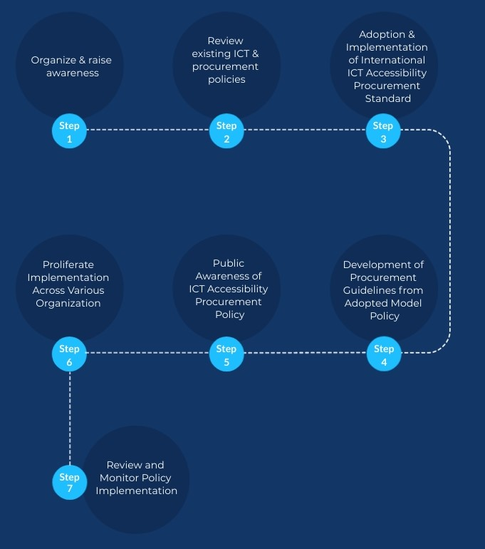
Figure 3: Steps for adopting an Accessible Procurement Policy

4. Conclusion

The adoption of accessible ICT by the public sector will significantly improve the ICT accessibility landscape on a national level leading to the provision of universal access and increased opportunities of education and employment for PWD. The implementation of an Accessible Procurement Policy should help encourage the industry manufacturers and vendors to recognize the marketplace and importance of developing solutions compliant to accessibility standards. The enforcement of such policies will provide strong incentives to the industry for working towards developing accessible solutions from their early stages of conceptualization which will be key to future success and sustainable incorporation of accessibility compliance. The consistent demand of accessible ICT goods and services generated from the policy will provide greater stability for the industry to invest and compete in the implementation and supply of accessible ICT solutions for the market.
Additional complimentary steps can be taken to support an Accessible Procurement Policy by working towards initiatives like funding the implementation of various Business Innovation and Incubation Programs to serve as incentive for independent innovators and startups to develop adequate, innovative accessibility compliant solutions to meet the market needs. The implementation of such programs will offer a complete incentivized ecosystem for the industry and marketplace to be a driving force for developing innovative groundbreaking solutions to meeting the accessibility ICT needs of the PWD community.

References
[1] ITU. (2019). Standards in the Procurement of Accessible ICT Products and Services Draft.
https://www.itu.int/en/ITU-T/Workshops-and-Seminars/20190325/Documents/Draft%20Standards%20in%20the%20Procurement%20of%20Accessible%20ICT%20Products%20and%20Services.pdf
[2] European Telecommunications Standards Institute (2014). Accessibility requirements suitable for public procurement of ICT products and services in Europe. https://www.etsi.org/deliver/etsi_en/301500_301599/301549/01.01.01_60/en_301549v010101p.pdf
[3] Section 508. (2017). Section 508 of the Rehabilitation Act. https://www.fcc.gov/general/section-508-rehabilitation-act
[4] G3ICT. (2019) Procurement of ICTs for Inclusive Government and Public Sector: Guide for Engaging ICT Vendors.
https://g3ict.org/publication/public-procurement
[5] Astbrink, G., & Tibben, W. (2013). ICT Accessibility Criteria in Public Procurement in OECD Countries – The Current Situation. Universal Access in Human-Computer Interaction. Design Methods, Tools, and Interaction Techniques for EInclusion.
https://doi.org/10.1007/978-3-642-39188-0_17
[6] ITU & G3ICT. (2014). Model ICT Accessibility Policy Report. https://www.itu.int/en/ITU-D/Digital-Inclusion/Pages/Digital_Inclusion_Resources/Model_ICT_Accessibility_Policy.aspx#:~:text=This%20report%20is%20a%20practical,empowerment%20of%20persons%20with%20disabilities.

[7] UNESCO. (2014). Model Policy for Inclusive ICTs in Education for Persons with Disabilities.
http://www.unesco.org/new/en/communication-and-information/resources/publications-and-communication-materials/publications/full-list/model-policy-for-inclusive-icts-in-education-for-persons-with-disabilities/

[8] G3ICT. Guide to Implementing Priority ICT Accessibility Standards. https://smartcities4all.org/SC4A_Toolkit_-_Standards_XT.php
[9] G3ICT. 9 Steps to Procuring Accessible ICTs for Inclusive Education.
Roadmap-to-accessible-ICT-procurement_XT.pdf (g3ict.org)
[10] G3ICT. E-Accessibility Policy Toolkit for Persons with Disabilities.
Homepage-e-accessibilitytoolkit.org (e-accessibilitytoolkit.org)
[11] GOV.UK. (2018). Understanding Accessibility Requirements for Public Sector Bodies.
Understanding accessibility requirements for public sector bodies - GOV.UK (www.gov.uk)
[12 ] NDA. Principles of Accessible Procurement. http://universaldesign.ie/Technology-ICT/IT-Procurement-Toolkit/Supporting-Information/Principles-of-accessible-procurement/

Appendix 1 – Abbreviations
ADA | American Disability Act
ADAAG | ADA Accessibility Guidelines for Buildings and Facilities
ATAG | Authoring Tools Accessibility Guidelines
AT | Assistive Technology
ETSI | European Telecommunications Standards Institute
G3ICT | Global Initiative for Inclusive ICTs
ICT | Information and Communication Technology
OECD | Organization for Economic Co-operation and Development
PWD | Persons with Disabilities
SDG | Sustainable Development Goals
UD | Universal Design
UNCRPD | United Nations Convention on the Rights of Persons with Disabilities
W3C | World Wide Web Consortium
WCAG | Web Content Accessibility Guidelines

Appendix 2 – Core Assistive Technologies

A checklist of core assistive technologies that may be encountered in organizations is useful. Assurance of the compatibility with the Operating system and learning platform can be requested from those tendering to deliver the resources.
A useful list to start with is

Solutions for people with a Visual Impairment
- A screen reader
- A magnifier
- Accessibility options – Magnifier and Narrator
- CCTV/Hand held magnifiers

Solutions for people with Physical Needs
- Full on screen keyboard
- Operating system on screen keyboard
- Voice recognition
- Alternative access devices including Switches, touch screen, joystick, eye tracker, head pointer, variety of keyboards and pointing devices

Solutions for people with communication needs
- Symbol processor
- Text prediction
- Induction loop
- Captioned video

Solutions for people with Dyslexia
- Word Prediction packages
- Screen Tinting software
- Voice recognition
- Digital voice recorders

Appendix 3 – Clarification of Tender

A checklist of questions when seeking clarification of tender
Sometimes it is useful to have a range of very specific questions to ask around a type of product. The checklist of questions below can be of value in generating output specifications and in prompting suppliers to give meaningful answers.

Aspect | Issue | Evidence
Hardware – Platform | How will the platform support a range of third party input and output devices.? | Identify key solutions used and ask for confirmation of testing
 | What connectivity to third party input/output devices will be available? | Specify current connections and the ability to upgrade if necessary. Include both hard and wireless connections
 | Is the hardware compatible with widely used access software solutions? | Create a minimum specification for processor, memory, hard drive, video and sound cards to support your test list of solutions
 | Will drivers for input/output devices be available on this platform ? | Ensure these will be preinstalled onto the network
 | What support can be provided for input/output based on legacy connections? | Will the workstation support adapters from USB to serial etc

Hardware – Laptops | What range of screen size will be available? | Look for small screen size for portability coupled with larger screen including widescreen for those with a visual impairment
 | How much do any specified portable devices weigh? | For people with physical needs a suitable weight should be specified
 | Are ruggedized devices available? | Specify potential provision of laptops with additional ruggardization to protect if dropped from a height of 5ft
 | How do the devices open and start up – Ease of use? | Ask for details of catches to open and if the machine can  automatically start-up with no further key presses required
 | What is the battery life  In Hibernate  In continuous use? | Request confirmation from provider of these details – Assume that devices may need to run for up to four hours without charging as a worst case
 | Can the selected device accommodate peripherals such as scanners, CCTV/magnifiers, joysticks? | Request confirmation of range of peripherals tested

Teaching and Learning Technology (for schools and training)) | Can Interactive whiteboards (IWB) be height adjusted? | Identify the range of heights that the IWB can be positioned at
 | How will IWB be accessed? | What devices can be utilised to access the IWB, do these include the potential for third party access devices
 | What alternative access solutions will operate with IWB? | Specifically request information on both hardware peripherals and access software
 | Will Slates operate with the system? | Request confirmation from provider
 | Can images of IWB be viewed locally? | Request confirmation from provider
 | What technologies are used to access pupil voting methods? | Specifically request information on both hardware peripherals and access software
 | Will the technology integrate with CCTV and sound systems? | Examples of integration
Managed Services | How will local specialist technician knowledge integrate with provider services? | Request information and schedule of communications and routes previously applied
 | What provision of instant replacement services is applicable to people with a disability? | Ensure that backups of user files will be reinstalled
 | Can the systems be accessed by users of non standard technologies? | Ask for details of non standard access delivered in previous implementations
 | Will users have access to the control panel features? | Request confirmation from provider
 | Can user profile for accessibility features be accessed at login anytime anywhere? | Request details of how this will be delivered
 | What are the timescales and related dependencies for approval and installation of access technologies? | Periods longer than 10 days should be rejected
Operating System | What accessibility options are available in the operating system? | Request confirmation from provider – use out of the box implementation of MS windows as benchmark
 | What third party access software is available? | Request list for range of needs
 | How will non keyboard or non literate users log on to the system? | Look for alternative access to login to accounts including fingerprint recognition and on screen keyboard
Applications | What range of applications will run on the system and will those option work with assistive technologies? | Request legacy list from IT Team and match to that provided by supplier
Intranet or Learning Platform | Will the platform comply with accessibility standards? | Utilise w3c standards as starting point – with confirmation of manual tests
 | How will any bundled content created for the platform be managed - How will the accessibility of content be assured? | Identify how staff will be supported and which elements of accessibility can  be tested automatically in the creation process
 | Can it be accessed by users of non-standard technologies? | See managed services
 | Is network licensing of assistive technologies appropriate? | Request pricing and support costs
 | How will Assistive technologies be maintained in line with OS and application upgrades? | What specialist knowledge will be available
 | Are drivers for assistive technologies preloaded onto the system? | Request confirmation of approved driver list
Building Design and Furniture | Are suitable power sockets and network access points available to support pupils throughout the organisations environment? | Sockets should meet a range of needs and should include underfloor and waist height sockets
 | Is furniture accessible and suitably adjustable for individual needs? | Request details of how furniture is adjusted for ease of use
 | Is technology sited for ease of access? | Look at space constraints for powered chair users and ease of transfer from mobility aid to seating
 | Does Lighting reflect on the screen or create undue glare?  Can it be locally adjusted (e.g. turned off.)? | Request confirmation of issue considered
 | Is there sufficient space allowed in the workspace for equipment to be manoeuvred  and to promote access for people with limited mobility? | Request details of previous implementation in environments for mixed needs

Appendix 4 - Functional Performance Statements

The following two standards, EN 301 549, “Accessibility requirements for public procurement of I T products and services in Europe” and Section 508, U/S/ Rehabilitation Act of 1973, provide a framework which may be used to define ICT accessibility for procurement purposes. Although similar in scope and content, it is recommended not to alter the text of these statements or to mix and match them.

EUROPEAN: Functional performance statements from EN 301 549 “Accessibility requirements for public procurement of ICT products and services in Europe”
- Meeting functional performance statements
- The statements set out in this box are intended to describe the functional performance of ICT enabling people to locate, identify, and operate ICT functions, and to access the information provided, regardless of physical, cognitive or sensory abilities. Any ability impairments may be permanent, temporary or situational.
- ICT meeting the applicable requirements of clauses 5 to13 is deemed to have met a level of accessibility conformant with the present document and consistent with the user accessibility needs identified in clause 4.2 (Functional performance statements).
- NOTE 1: The relationship between the requirements from clauses 5 to 13 and the accessibility-related user needs is set out in Annex B.EN 301 549 V1.1.1 (2014-02)
- NOTE 2: The intent of clause 4.2 is to describe the users' accessibility needs in accessing the full functionality and documentation of the product or the service with or without the use of assistive technologies.
- NOTE 3: The methods of meeting the accessibility needs of users with multiple impairments will depend on the specific combination of impairments. Meeting these user accessibility needs may be addressed by considering multiple clauses in 4.2.
- NOTE 4: Several users' accessibility needs rely on ICT providing specific modes of operation. If a user is to activate, engage or switch to the mode that complies with his or her user accessibility needs, the method for activating, engaging or switching to that mode is also expected to comply with the same user accessibility needs.

- Functional performance statements
  - Usage without vision
- Where ICT provides visual modes of operation, some users need ICT to provide at least one mode of operation that does not require vision.
NOTE: Audio and tactile user interfaces may contribute towards meeting this clause.

  - Usage with limited vision
- Where ICT provides visual modes of operation, some users will need the ICT to provide features that enable users to make better use of their limited vision.
- NOTE 1: Magnification, reduction of required field of vision and control of contrast, brightness and intensity can contribute towards meeting this clause.
- NOTE 2: Where significant features of the user interface are dependent on depth perception, the provision of additional methods of distinguishing between the features may contribute towards meeting this clause.
- NOTE 3: Users with limited vision may also benefit from non-visual access (see clause 2.1).

- NOTE 2: Keyboard, pen or touch user interfaces may contribute towards meeting this clause.

  - Usage without perception of color
- Where ICT provides visual modes of operation, some users will need the ICT to provide a visual mode of operation that does not require user perception of colour.
- NOTE: Where significant features of the user interface are colour-coded, the provision of additional methods of distinguishing between the features may contribute towards meeting this clause.

  - Usage without hearing
- Where ICT provides auditory modes of operation, some users need ICT to provide at least one mode of operation that does not require hearing.
- NOTE: Visual and tactile user interfaces may contribute towards meeting this clause.
  - Usage with limited hearing
- Where ICT provides auditory modes of operation, some users will need the ICT to provide enhanced audio features.
- NOTE 1: Enhancement of the audio clarity, reduction of background noise, increased range of volume and greater volume in the higher frequency range can contribute towards meeting this clause.
- NOTE 2: Users with limited hearing may also benefit from non-hearing access (see clause 2.4).EN 301 549 V1.1.1 (2014-02)

  - Usage without vocal capability
- Where ICT requires vocal input from users, some users will need the ICT to provide at least one mode of operation that does not require them to generate vocal output.
- NOTE 1: This clause covers the alternatives to the use of orally-generated sounds, including speech, whistles, clicks, etc.

  - Usage with limited manipulation or strength
- Where ICT requires manual actions, some users will need the ICT to provide features that enable users to make use of the ICT through alternative actions not requiring manipulation or hand strength.
- NOTE 1: Examples of operations that users may not be able to perform include those that require fine motor control, path dependant gestures, pinching, twisting of the wrist, tight grasping, or simultaneous manual actions.
- NOTE 2: One-handed operation, sequential key entry and speech user interfaces may contribute towards meeting this clause.
- NOTE 3: Some users have limited hand strength and may not be able to achieve the level of strength to perform an operation. Alternative user interface solutions that do not require hand strength may contribute towards meeting this clause.

  - Usage with limited reach
- Where ICT products are free-standing or installed, the operational elements will need to be within reach of all users.
- NOTE: Considering the needs of wheelchair users and the range of user statures in the placing of operational elements of the user interface may contribute towards meeting this clause.

  - Minimize photosensitive seizure triggers
- Where ICT provides visual modes of operation, some users need ICT to provide at least one mode of operation that minimizes the potential for triggering photosensitive seizures.
- NOTE: Limiting the area and number of flashes per second may contribute towards meeting this clause.

  - Usage with limited cognition
- Some users will need the ICT to provide features that make it simpler and easier to use.
- NOTE 1: This clause is intended to include the needs of persons with limited cognitive, language and learning abilities.
- NOTE 2: Adjustable timings, error indication and suggestion, and a logical focus order are examples of design features that may contribute towards meeting this clause.

  - Privacy
- Where ICT provides features that are provided for accessibility, some users will need their privacy to be maintained when using those ICT features that are provided for accessibility.
- NOTE: Enabling the connection of personal headsets for private listening, not providing a spoken version of characters being masked and enabling user control of legal, financial and personal data are examples of design features that may contribute towards meeting this clause.
- AMERICAN: U.S. Rehabilitation Act of 1973. Section 508 Standards for Electronic and Information Technology -Subpart C — Functional Performance Criteria

1194.31 Functional performance criteria.
- At least one mode of operation and information retrieval that does not require user vision shall be provided, or support for assistive technology used by people who are blind or visually impaired shall be provided.
- At least one mode of operation and information retrieval that does not require visual acuity greater than 20/70 shall be provided in audio and enlarged print output working together or independently, or support for assistive technology used by people who are visually impaired shall be provided.
- At least one mode of operation and information retrieval that does not require user hearing shall be provided, or support for assistive technology used by people who are deaf or hard of hearing shall be provided.
- Where audio information is important for the use of a product, at least one mode of operation and information retrieval shall be provided in an enhanced auditory fashion, or support for assistive hearing devices shall be provided.
- At least one mode of operation and information retrieval that does not require user speech shall be provided, or support for assistive technology used by people with disabilities shall be provided.
- At least one mode of operation and information retrieval that does not require fine motor control or simultaneous actions and that is operable with limited reach and word

Appendix 5 - Example of Product Accessibility Template

The following example product accessibility template may be attached to the Call for Tender for completion by the supplier. To the greatest extent possible the format of any such template should be based on a similar template used in other regions for use with the standards cited in Annex B. The following example is based on the “Government Product Accessibility Template” provided by the Buy Accessible Wizard at Government Product Accessibility Template

The template should include, at a minimum,
- A clear reference to the procurement competition for which it is to be used
- A clear reference to the subject matter of the procurement
- A clear reference to the standard from which the accessibility requirements are taken

←--- Example template starts here---→

Product accessibility for [name of competition and ICT to be procured]
Summary table: This table provides a summary of all the relevant sections from the standard [name of standard in Annex B from which provisions are taken]
- Column one includes all the sections of the standard that may apply to any deliverable. The total number of provisions within each Section of the Standard is shown in parentheses. Column two identifies the total number of provisions that typically apply to a deliverable of this type. Some of these may not be features of the supplier’s deliverable/ conversely, others not noted may be features of the s
- upplier’s deliverable/ If the deliverable includes additional features, the accessibility of these features must also be considered.
- Column three is for general notes about the sections of the standard. Some apply to all deliverables and some are specific to the deliverable.
- Column four is a summary of the vendor’s response to applicable provisions and additional deliverable features from the sections of the standard.
- Column five is where the vendor can note explanations for any of the preceding columns, e.g. there are differences between expected applicable provisions and actual product features.

[e.g. Section 508, EN 301 549] Standard Sections | Total Number of Applicable Provisions | Notes | Total Number of Supported Provisions |  |  | Please explain
 |  |  | Fully | Partial | Not
Section [XX.xx] [Name of section] ([Number of] provisions) | [Number] | Section [XX.xx] [Name of section] ([Number of] provisions)
Section [XX.xx] [Name of section] ([Number of] provisions) | [Number] | Section [XX.xx] [Name of section] ([Number of] provisions)
etc | etc | etc

Subpart B --Technical Standards
Note. If there is a possibility that the provision applies, the default value is “Yes.

Provision Text | Applicable | Notes | How does the EIT meet this requirement? | Please explain
[Accessibility requirement taken from standard cited in Annex B – to be filled in by the supplier] | [Yes/No – to be filled in by procuring authority] |  | __Fully __Partially __No [to be filled in by supplier] [to be filled in by supplier] | [Accessibility requirement taken from standard cited in Annex B – to be filled in by the supplier]
[Accessibility requirement taken from standard cited in Annex B] | [Yes/No] |  | __Fully __Partially __No [Accessibility requirement taken from standard cited in Annex B]
[Accessibility requirement taken from standard cited in Annex B] | [Yes/No] |  | __Fully __Partially __No

Appendix 6 - 9 Steps to Procuring Accessible ICTs for Inclusive Education (G3ICT)

The objective of following actions and checklist is to support education system institutions towards a stronger commitment to accessibility in their ICT procurements through nine steps. Procurement is one of the most important and effective policy tools both for national education authorities and local school districts. Procurement requirements have a large influence on many areas, including the behaviors of markets, individual companies, and the lives of learners and their families, which is particularly true for persons with disabilities.

Actions | Description
- Organization and awareness-raising | At the first stage, it is useful to create a working group of stakeholders to ensure that common understanding is formed across the organization, all needs are noted, and awareness is raised:  - Identify the stakeholders of the ICT procurement process  - Create a working group comprised of the stakeholders: procurement officers, CIO/IT personnel, accessibility specialists, academic excellence specialists, administrators, teachers/professors, therapists, other education support professionals, etc. as well as users of the technology. Parents of students with disabilities could also be considered.  - Create a shared understanding and common language by organizing training on ICT accessibility in an education environment  - Ensure that the group receives the resources necessary to participate in the process  - Ensure that the group participates as appropriate and feasible in all stages of the procurement process, including drafting of Call for Tender/ Request for Proposals, evaluation of tender proposals, meetings with vendors, etc. At a minimum, it is important to keep all stakeholders informed of progress.
- Audit and research | To improve the general understanding of the accessible ICT for education landscape assess the needs and evaluate what the market can offer:  - Make yourself familiar with the existing national and regional ICT and procurement policies, international and national accessibility standards, including universal design approaches, interoperability guidelines, and procurement guidelines  - Refer to the national resource database of inclusive ICT procurement possibilities, if one exists  - Investigate if there are resource centers for assistive technologies who might also advise on accessibility  - Research the experience of other education system institutions with different ICT solutions and ICT companies  - Arrange an audit of students to assess the education environment and needs across the country or in the single education system institution  - Assess the current state of the ICT ecosystem of the education system institution to check what ICTs have already been purchased and whether they are accessible  - Come up with the list of the education system institution’s ICT accessibility needs, which will benefit all the learners  - Engage with vendors and suppliers and learn what is available on the market
- Engagement of vendors in a discussion | Discuss with vendors ICT accessibility strategies, approaches, and commitment. Refer to the G3ict document, Procurement of ICTs for Inclusive Education: Guide for Engaging ICT Vendors, for tips on having a more meaningful dialogue about accessibility with vendors:  - Organize a series of meetings with vendors that have been selected as meeting accessibility criteria in a Call for Tender/RFP  - Clarify how vendors’ products can be used to meet specific accessibility needs and requirements  - Ask questions regarding the vendor’s experience in accessibility and what business processes ensure the accessibility of the products  - Request demonstrations of a vendor’s product within the planned setting with the focus on its accessibility and application for different use cases including individual use and collaboration
- Call for Tender/Request for Proposals | - Send out to potential vendors the precise details of the product or service required, including accessibility requirements, and terms of the procurement exercise  - Make sure that accessibility criteria are clear, add references to guiding documents to educate and raise awareness among vendors  - Request evidence, such as conformance report, to show there is a conformity with the accessibility criteria  - Request testimonials of successful implementation of accessible products  - Make it clear that adherence to accessibility standards is a condition for successful requests and will be included in the final contract.
- Evaluation of tenders | - Use this stage as an additional opportunity to engage vendors in productive discussions regarding ICT accessibility  - Evaluate each vendor response against the criteria set out in the call for tender  - Request that vendors self-declare how they meet accessibility criteria in a conformance report and make it optional for them to include supplemental information such as supporting evidence or third-party assessments, etc.
- Evaluation of deliverables | - Ensure the deliverables meet the criteria set out in the tender  - If you have concerns about usability, consider asking the vendor to let some users with disabilities within your organization pilot or trial the product or service
- Contracts management | - Define the process for handling exceptions to standards and requirements  - Agree on deployment and support procedures making sure that accessibility is covered by the vendor’s dedicated support team  - Include all relevant information on accessibility guarantees, testing and delivery  - Include provision for soliciting feedback from both vendors and users  - Consider a non-payment clause if the contractually agreed accessibility criteria are not delivered.
- Deployment | To ensure equal access to education for all learners and maximize return on investment it is important to ensure timely and full deployment of purchased accessible ICT:  - Discuss with vendors access to their training materials, opportunities for online and offline training  - Give feedback to vendors on the deployment and use of their products for them to be able to improve it  - Join knowledge-sharing communities  - Build partnerships with vendors, other education, and academic institutions, and civil society, initiate discussions, participate in dialogues
- Education and training | To ensure that an education organization takes full advantage of its investments into accessible ICT, consider providing training and guidance to all stakeholders, including staff, teachers, learners, and parents:  - Assess the training needs of all groups of stakeholders  - Create accessibility training plan  - Engage vendors as well as persons with disabilities in the development and delivery of the training materials Consider “train the trainer” option to scale up the plan and reach a wider audience  - Solicit feedback and incorporate it into the training plan  - Update and deliver training on the regular basis

Appendix 7 - The Five Procurement Stages
It is critical to outline the existing procurement process in terms of five procurement stages identified in the international procurement standards. This mapping process usually involves identifying and aligning gaps within the existing procurement stages to embed ICT accessibility procurement needs. Each procurement stage must have corresponding response timelines based on the range of activities (e.g. approval timeline, clarification timeline, etc.). Following are the crucial five procurement stages necessary and the relevant activities associated to them for implementing an accessible procurement guideline and policy:
- Preparatory Study:
- Prior to a procurement cycle, preliminary study must be conducted to establish the organizational and user needs (including accessibility needs) for the ICT goods and/or services to be procured.
- The prospective vendors to be invited for Call for Tender must be studied for their competency to be able to offer the required goods and/or services.
- Call for Tender:
- Details (including technical specifications and standards) of the goods and/or services to be procured is to be drawn up and sent out to prospective vendors qualifying to fulfil the order.
- As part of the stage of Call for Tender, all invited vendors will be requested to demonstrate conformity of their solutions to meet the specified accessibility criteria.

- Evaluating tenders:
- An Evaluation Criteria must be drawn up to indicate the “acceptance criteria” of the goods and/or services being proposed by the vendors in response to the Call for Tender.
- The vendor responses received to the Call for Tender are evaluated based on the set out evaluation criteria.
- Part of the evaluation criteria could include allowing vendors with the opportunity to present provision of accessible goods/services related compliance self-declarations, self-declarations with supporting evidence, self-declarations with results from third party assessments certificates, etc.

- Evaluating Deliverables:
- Upon selecting the appropriate vendor to procure from (based on the vendor proposals received from the Call for Tender), the goods and/or services being delivered must be evaluated against measurables set out as part of the “Acceptance Criteria” in the Evaluation Criteria.
- The procurement stage of Evaluating Deliverables could involve steps like user-testing of the delivered solution(s) by people with disabilities.

- Contract Management:
- Accessibility Clauses must be adopted and incorporated into management of contracts.
- Process for handling exceptions and for soliciting feedback from both vendors and users may be included as part of the contract management stage as this is particularly relevant for procurement of ICT services.

https://www.fcc.gov/general/section-508-rehabilitation-act
https://www.etsi.org/deliver/etsi_en/301500_301599/301549/01.01.01_60/en_301549v010101p.pdf
Web Content Accessibility Guidelines (WCAG) 2.0 (w3.org)
https://www.fcc.gov/general/section-508-rehabilitation-act
https://www.etsi.org/deliver/etsi_en/301500_301599/301549/01.01.01_60/en_301549v010101p.pdf
Web Content Accessibility Guidelines (WCAG) 2.0 (w3.org)
Model ICT Accessibility Policy Report (itu.int)
http://www.unesco.org/new/en/communication-and-information/resources/publications-and communication-materials/publications/full-list/model-policy-for-inclusive-icts-in-education-for-persons-with-disabilities/
https://g3ict.org/publication/public-procurement

